GARDEN APPLICATION FORM
Orchid Garden Conservation Network (OGCN)
Name: Orchidarc Reserve & Collection
Type: Reserve and Private Collection
Location: Ixhuacán de los Reyes, Veracruz, Mexico

1. OVERVIEW
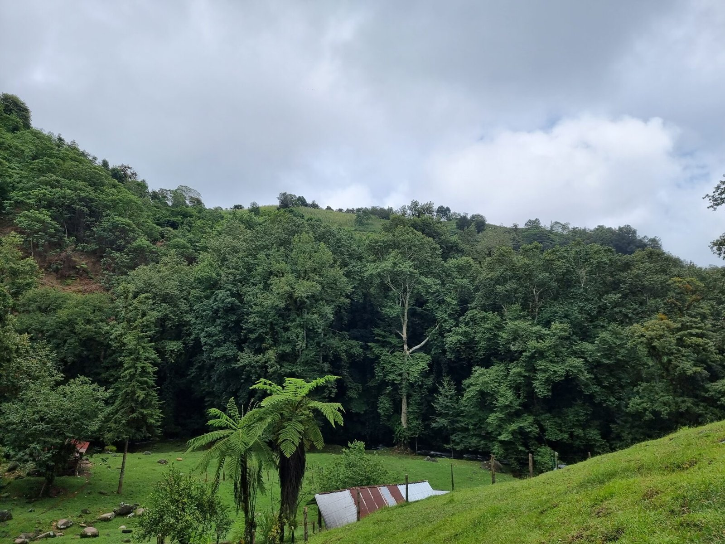
The Orchidarc Reserve, Ixhuacán de los Reyes, Veracruz
Year Founded: 2024 (Orchidarc registered as a UK charity, no. 1208062). The land has been in the family since the 1990s.
Approximate Area: 14 ha, of which about 2 ha (≈20%) is remnant riparian cloud forest
Altitude: 1,600 m above sea level
Brief description: The Orchidarc Reserve is a 14-hectare family conservation site in the cloud-forest region of Ixhuacán de los Reyes, central Veracruz, managed by Orchidarc, a UK-registered conservation charity working on the wild orchids of Mexico through research, action and cinema. Most of the land was converted to pasture, maize and cattle long ago, but a steep ravine, a rocky outcrop and a stream protected a remnant of living cloud forest. Its old oaks, Platanus and Liquidambar trees are draped with epiphytic orchids, bromeliads, aroids and mosses, and this small patch holds roughly 50 native orchid species, three of them on the Mexican Red List (NOM-059). Alongside the reserve, the family house holds an ex situ collection of about 1,000 specimens of some 500 species, mostly Mexican, with an emphasis on Lepanthes, Acineta and Laelia. The reserve is also the first stop of Orchidarc's guided orchid tours and a field base for research and documentary filmmaking.
Quote: "Conservation begins where the forest survived. Our purpose is to protect the remnant, expand native tree cover and use guided visits to show why these landscapes matter." Andrés Ramos, Director, Orchidarc

2. COLLECTIONS & BIODIVERSITY
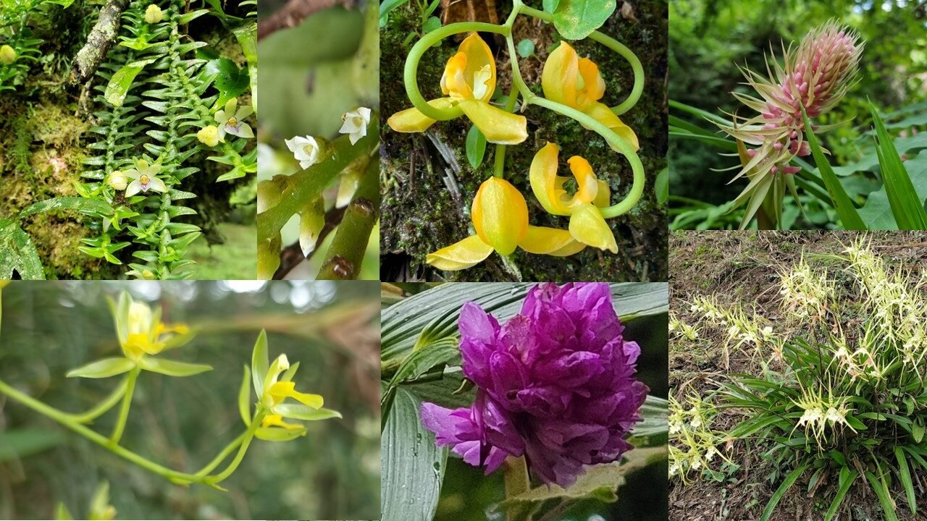
Flowering orchids documented at the Orchidarc Reserve
Approximate number of orchid species in cultivation: About 500, mostly Mexican, with an emphasis on Lepanthes, Acineta and Laelia
Approximate number of specimens in cultivation: About 1,000
Approximate number of specimens found wild: Wild populations of roughly 50 native species in the reserve's remnant forest, including three species on the Mexican Red List: Acineta barkeri, Prosthechea vitellina and Rossioglossum beloglossum
Species identified in the reserve to date: Acineta barkeri, Brassia verrucosa, Chysis laevis, Coelia macrostachya, Comparettia falcata, Dichaea glauca, Dichaea neglecta, Dichaea squarrosa, Elleanthus cynarocephalus, Encyclia candollei, Encyclia gravida, Epidendrum longipetalum, Epidendrum propinquum, Epidendrum pseudoramosum, Epidendrum repens, Epidendrum veroscriptum, Gongora galeata (including the form aurea), Isochilus major, Jacquiniella globosa, Jacquiniella teretifolia, Laelia anceps, Leochilus leiboldii, Leochilus oncidioides, Lophiaris pachyphylla, Lycaste aromatica, Lycaste deppei, Ponthieva tuerckheimii, Prescottia stachyodes, Prosthechea ochracea, Prosthechea vitellina, Rossioglossum beloglossum, Specklinia tribuloides, Stelis pachyglossa, Stelis platystylis.

3. VISITING INFORMATION
Access: By appointment only / Guided visits only. Steep walk-in access; visits are part of Orchidarc's guided orchid tours of Veracruz and Oaxaca.
Days: By appointment
Hours: Daylight hours, by arrangement

4. FACILITIES & AMENITIES
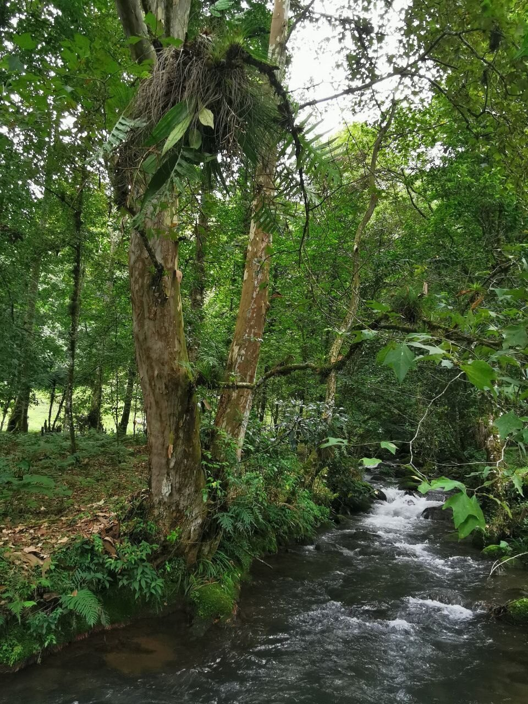
Stream and riparian corridor inside the reserve
Facilities & amenities: Forest trails through the ravine and along the stream, riparian cloud forest, ex situ orchid collection at the family house, field base for research and documentary filming.

5. PROJECTS & RESEARCH
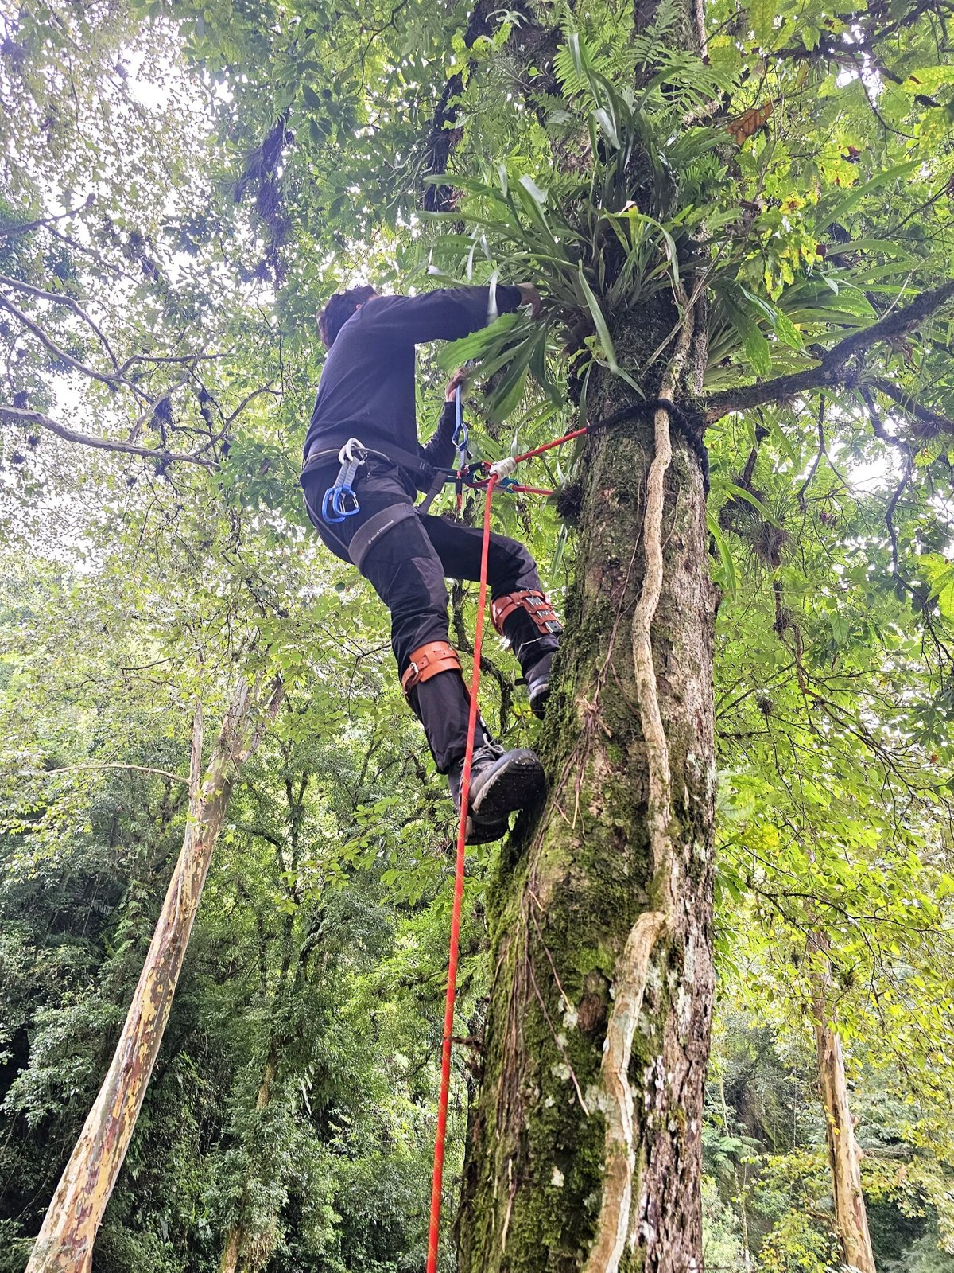
Canopy work at the reserve
Project & research:
- Revision of the genus Lepanthes in Mexico (about 34 taxa across Veracruz and Oaxaca), with Dr Rodolfo Solano (IPN), Herbario AMO and Mexican students.
- Symbiotic and in vitro propagation of threatened species and reintroduction work with Universidad Veracruzana, including regional protected areas such as La Martinica.
- Description of the Mexican endemic natural hybrid Dinema × mariae (published as ×Dinedema mariae, Phytotaxa 2025).
- A shade house for propagation at the reserve, supported by an American Orchid Society Conservation Grant.
- IUCN Red List assessments of Mexican orchids (the Director is a member of the IUCN SSC Orchid Specialist Group and a trained Red List assessor), and PhD research at the University of Tokyo on orchid pollinarium adhesives.
- Documentary films: Lily of Allsaints (Best Feature Environmental Documentary, FICAA Mexico City, 2025), Spring Orchids: Mexico, and the feature Orchids of Mexico, in development.

6. CHALLENGES
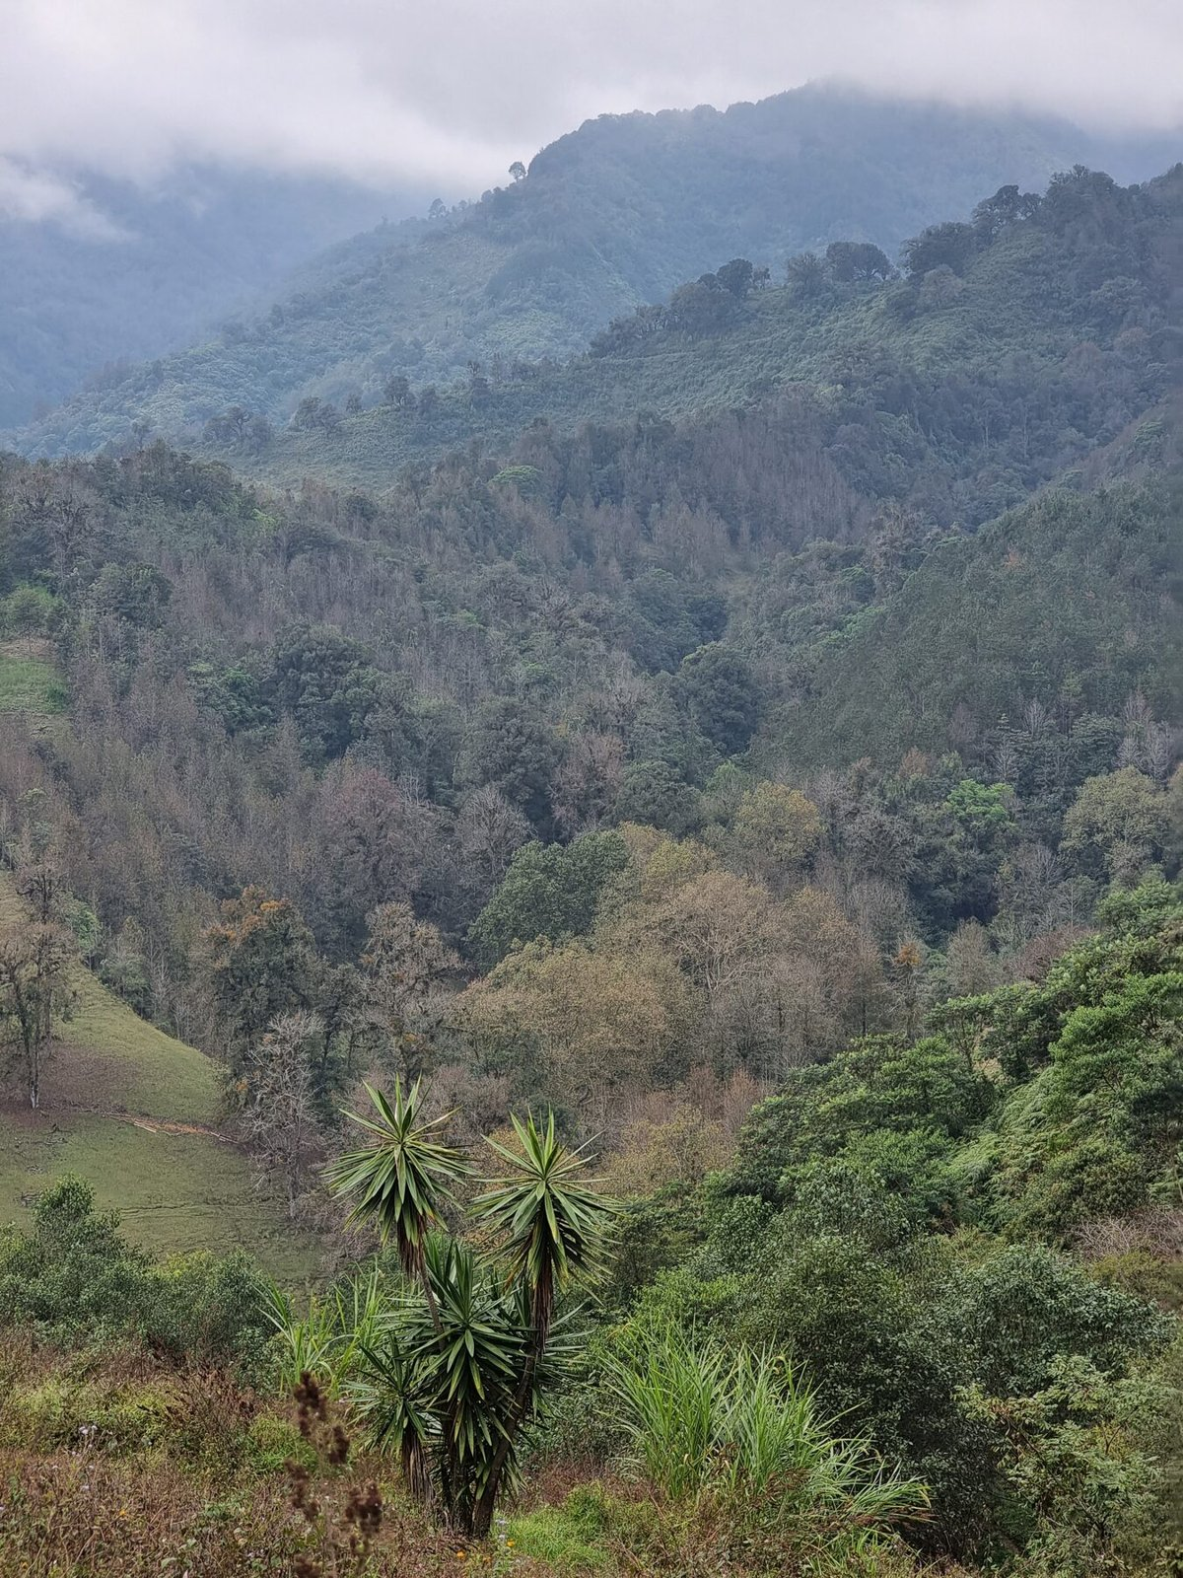
The reserve seen from the surrounding landscape: remnant forest within pasture
List:
- Cattle grazing and pasture on about 12 of the 14 hectares
- Difficult access to the site, which makes bringing in building materials laborious (a road is being negotiated with neighbours)
- Illegal collection and trade of wild orchids in the region
- Cloud-forest fragmentation and agricultural conversion across the surrounding landscape
- Managing the site remotely while the Director completes a PhD in Japan

7. FUTURE
List:
- Ending grazing and rewilding the altered land with oaks, riparian trees and other native host trees
- Building the shade house and increasing native orchid propagation and reintroduction
- Expanding guided orchid tours, education and community outreach
- Completing Red List assessments for the reserve's and region's threatened species
- Seeking funding for conservation and restoration projects
- Developing bilingual educational resources and documentary films

8. IMAGES OF EMBLEMATIC SPECIES
Photographs: Orchidarc. Please credit "Orchidarc" or "Andrés Ramos / Orchidarc" in the watermark.
1. Acineta barkeri (Mexican Red List, wild in the reserve)
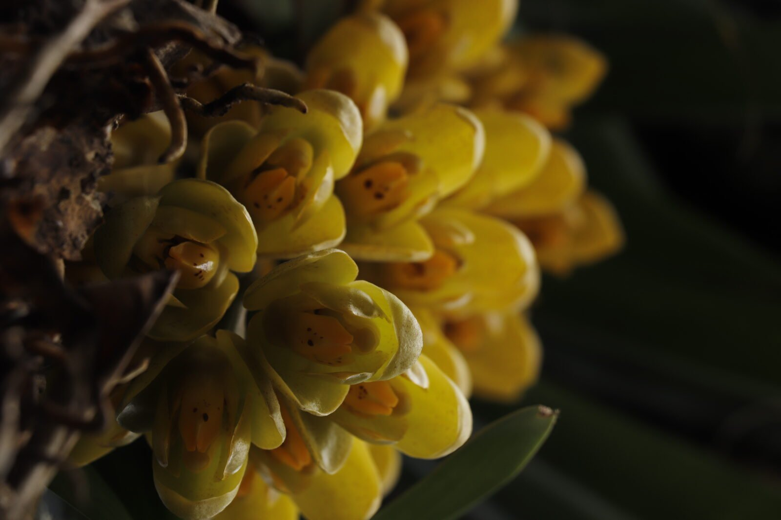
2. Prosthechea vitellina (Mexican Red List, wild in the reserve)
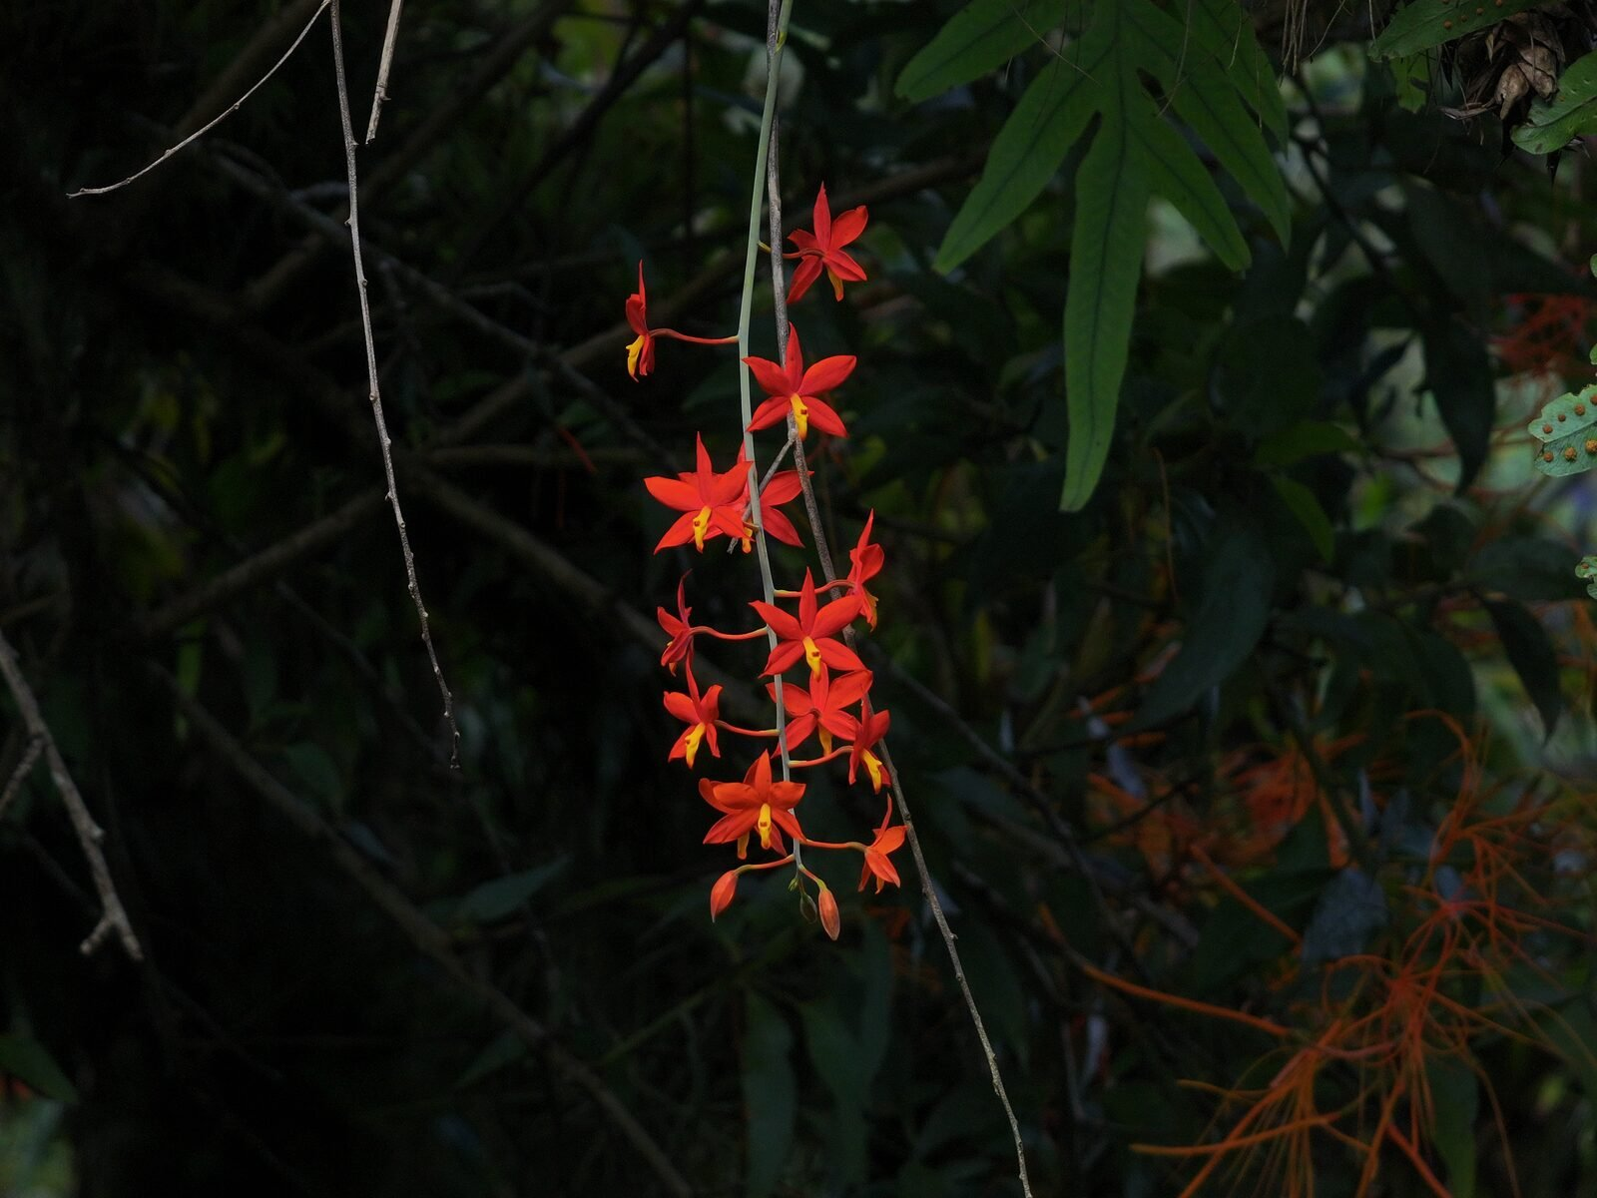
3. Coelia macrostachya (wild in the reserve)
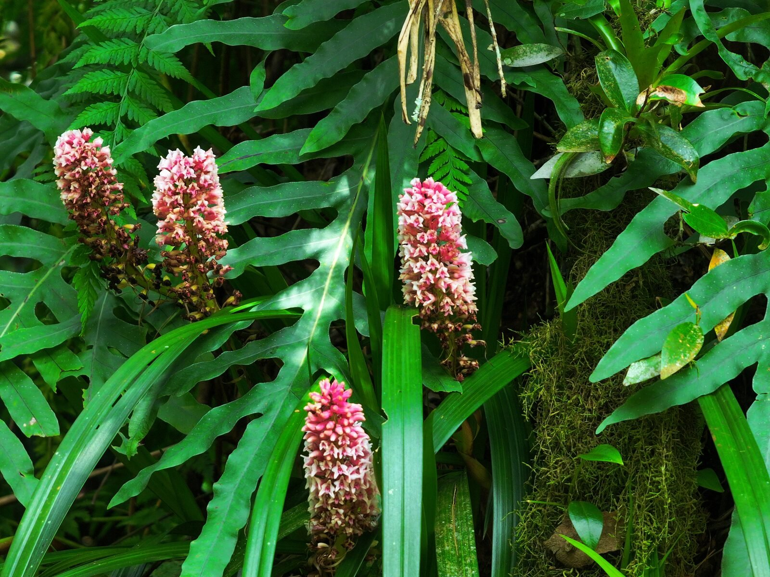
4. Dinema × mariae (in the collection; described by Orchidarc, endemic to Mexico)
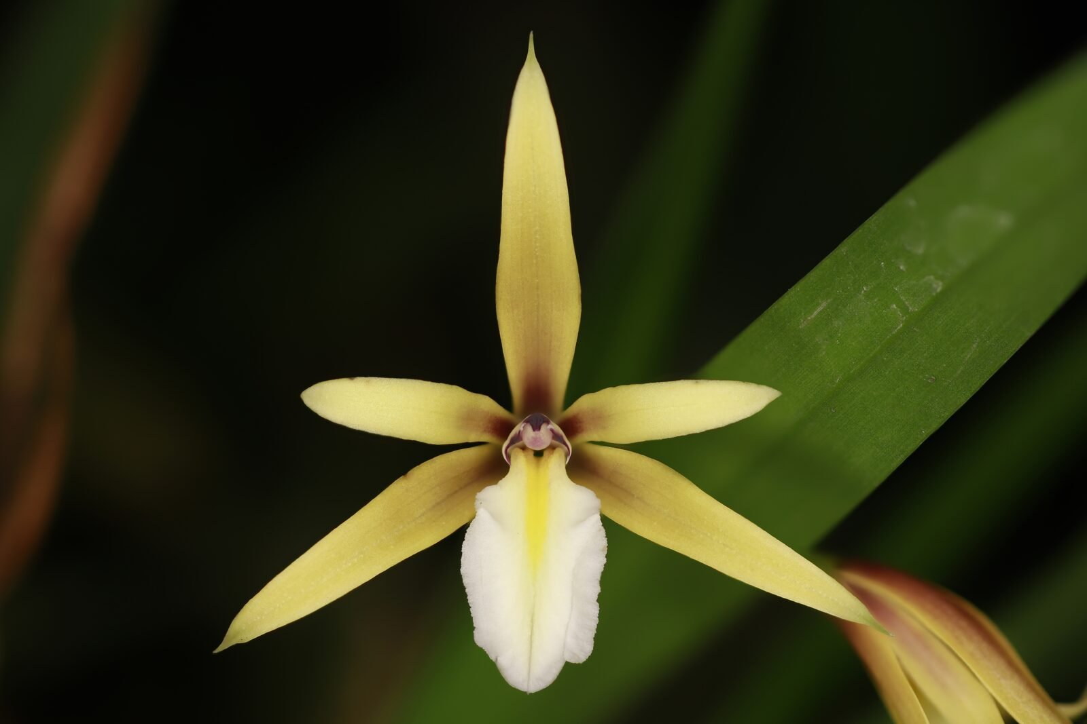
5. Laelia anceps (wild in the reserve; photographed on expedition)
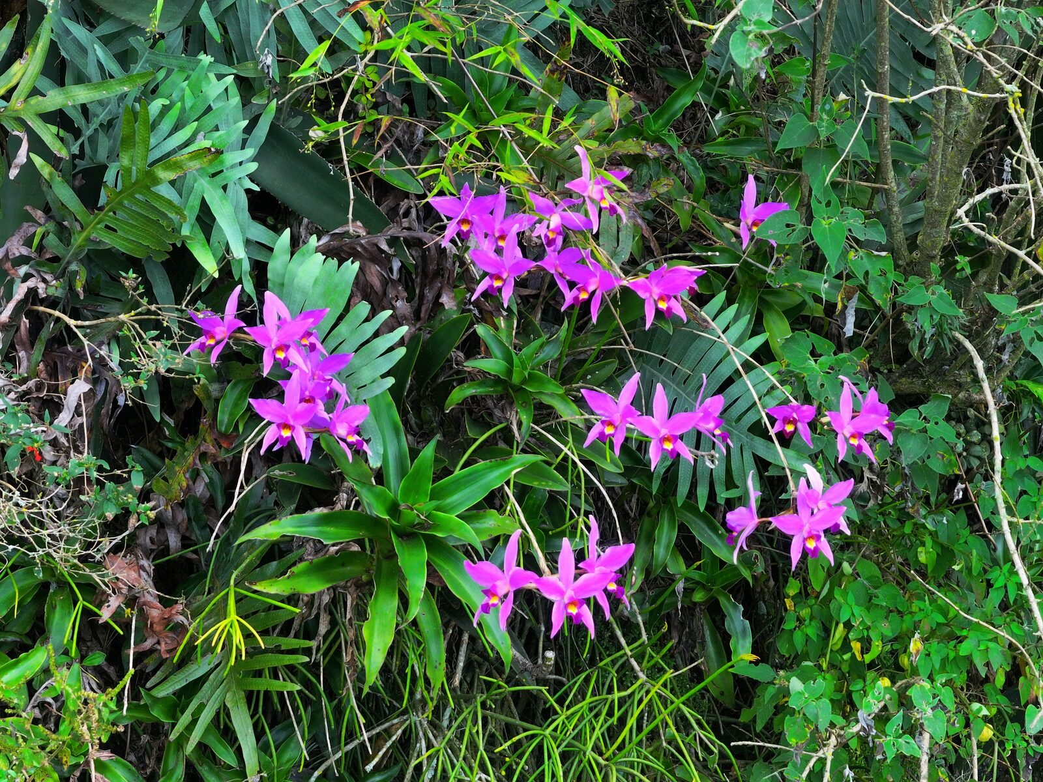
6. Laelia halbingeriana (in the collection)
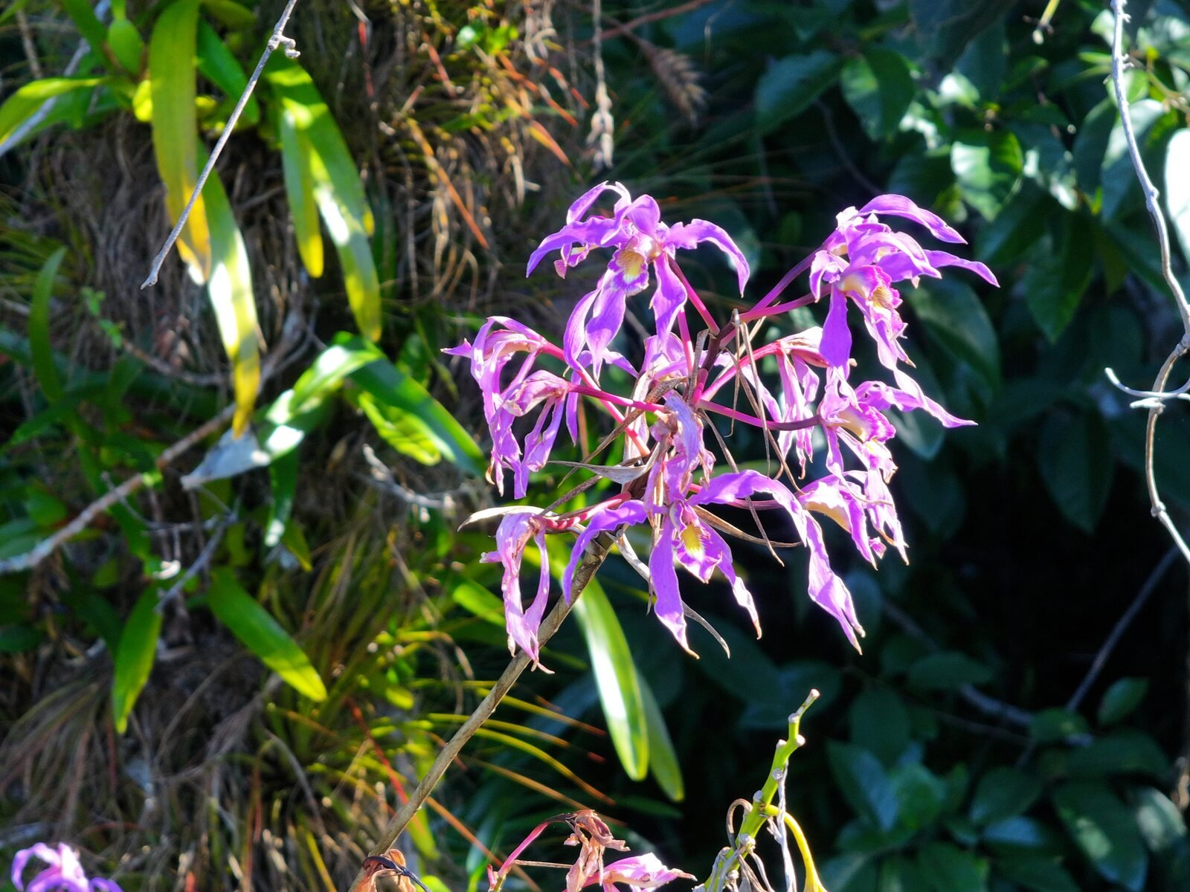
7. Lepanthes moorei (in the collection)
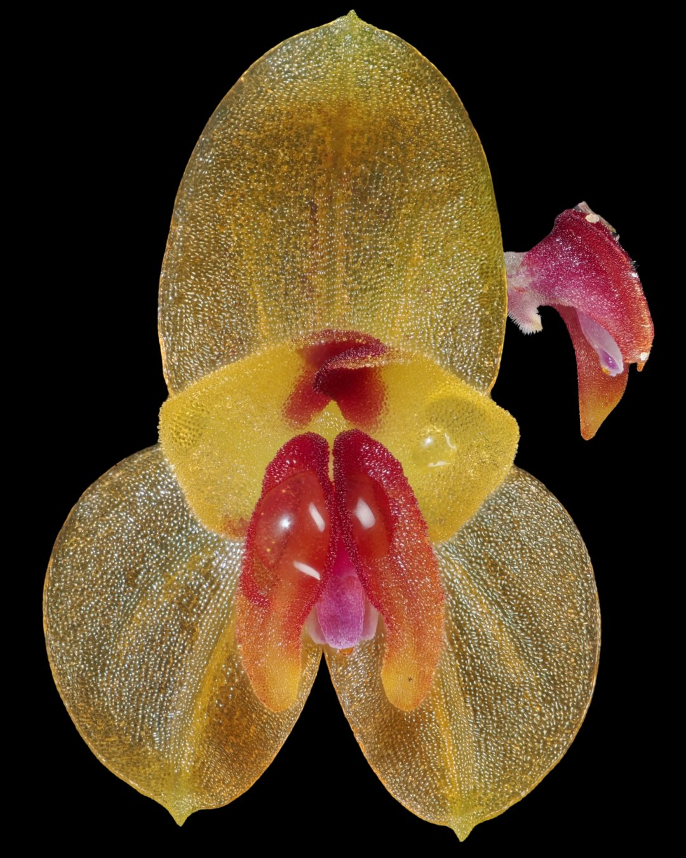
8. Lepanthes machorroi (in the collection)
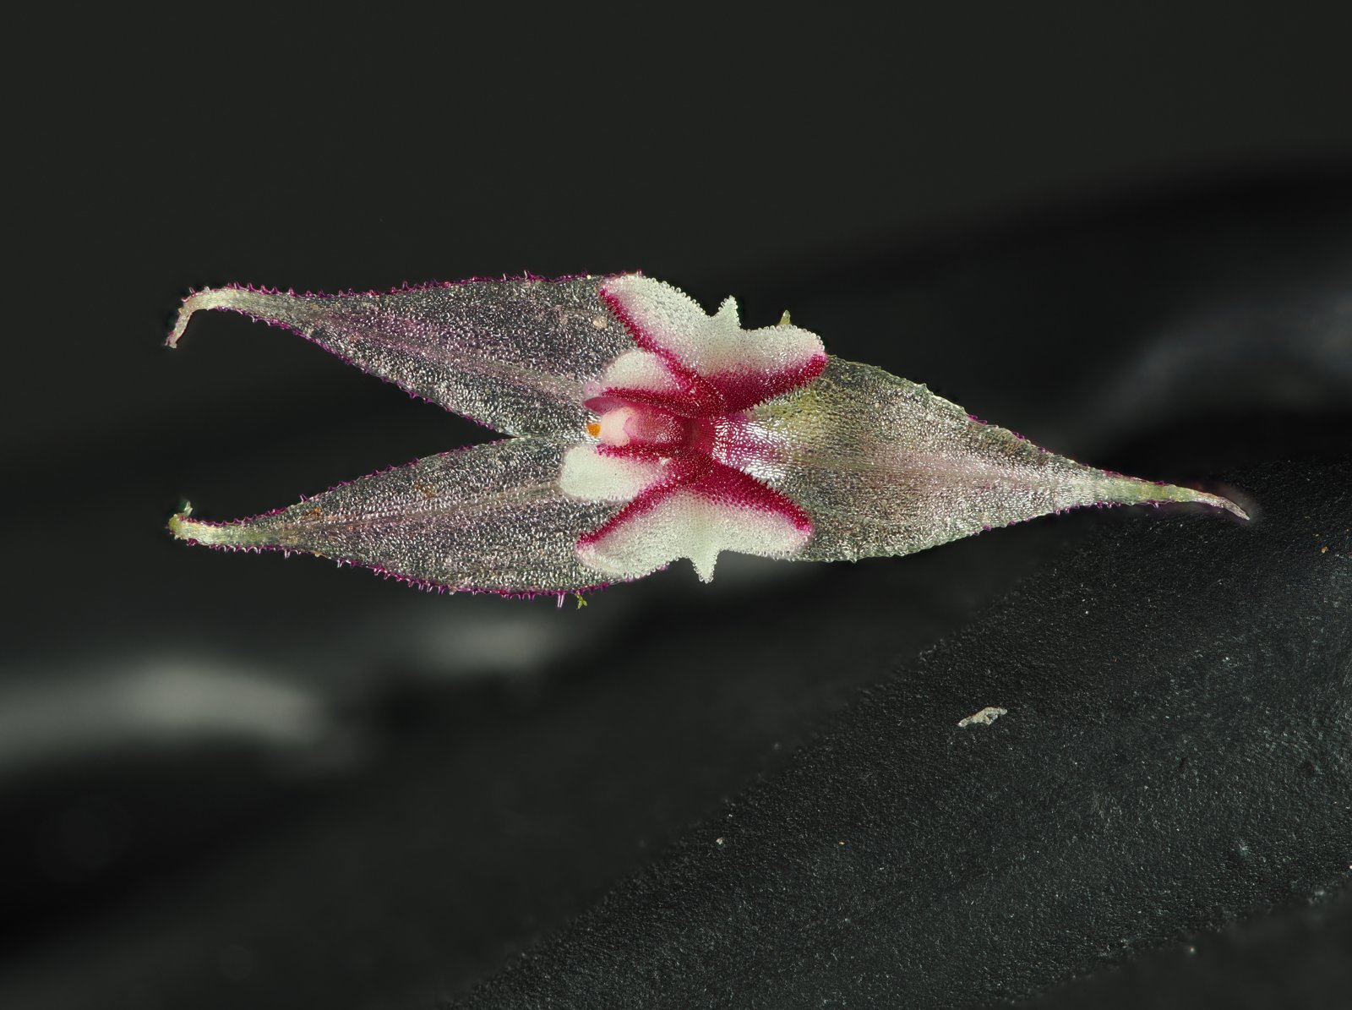
9. Lepanthes calopetala (in the collection)
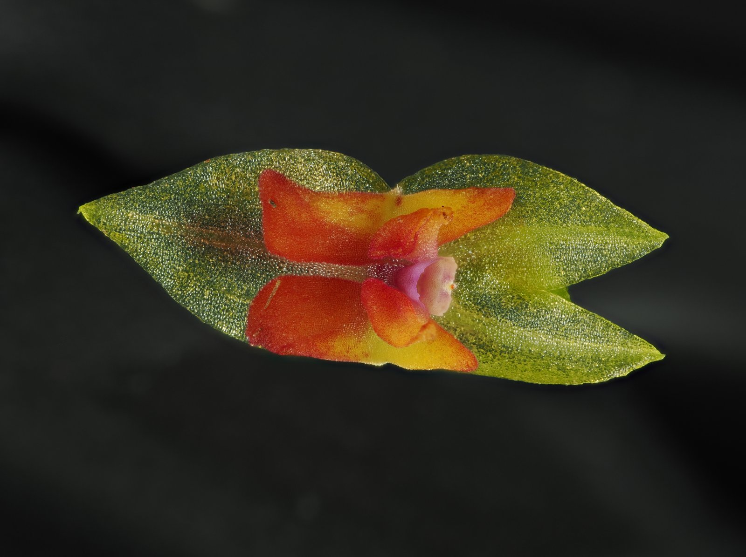

9. LINKS
Email: andresr@orchidarc.org
Website: https://orchidarc.org
Facebook: https://www.facebook.com/orchid.arc.2025/
Instagram: @orchidarcngo
YouTube: https://www.youtube.com/channel/UCTxs17CLsXiwm5GgsLcLMYQ

10. NOTES FOR THE OGCN TEAM
We are listing the reserve (in situ, about 50 native species) and the family collection (ex situ, about 1,000 specimens of 500 species) together, as they work as one conservation unit. We would love the page to link to our guided orchid tours (orchidarc.org/mexico-tours.html) and to our films. Higher-resolution images are available on request.

